CIA LABS

Designing a Social Discovery Experience for Campus Communities
Role: UX Research & Interaction Design
Project Type: Community Engagement Platform
Organization: Community in Atria Labs (CIA Labs), Atria Institute of Technology
Research Participants: 60 students across graduating years
Design Deliverables: User Journeys, 10+ User Flows, Homepage Redesign, AI-powered Discovery Experience

01. Project Overview
CIA Labs (Community in Atria Labs) wanted to create a more interactive way for students to connect with one another across the college. The idea was to build a campus-wide social discovery experience where students could scan each other's QR codes, guess their hobbies, discover shared interests, and earn points through gamified interactions.
The challenge wasn't simply building an application that supported QR scanning. It was creating an experience that students would actually enjoy using, understand without instructions, and be able to navigate effortlessly, regardless of their familiarity with technology or accessibility needs.
I worked on understanding student behaviour, identifying usability expectations, mapping user journeys, and designing the interaction flows that would bring the experience together.

02. Understanding the Users
Before jumping into Figma, I wanted to understand what actually makes a digital experience engaging for college students.
I conducted 60 user interviews across different graduating years, speaking with students to understand their expectations, how they interacted with campus communities, what made digital experiences enjoyable, and what could make them disengage.
Rather than assuming that gamification alone would make the platform engaging, I focused on understanding the friction students might encounter while navigating the experience.
I mapped the end-to-end user journey, from discovering the platform and accessing their QR code to scanning other students, participating in interactions, and earning rewards.
Key research takeaway: Students wanted the core interactions to be immediately accessible. Having to navigate through multiple screens just to access a scanner or display their own QR code would introduce unnecessary friction.
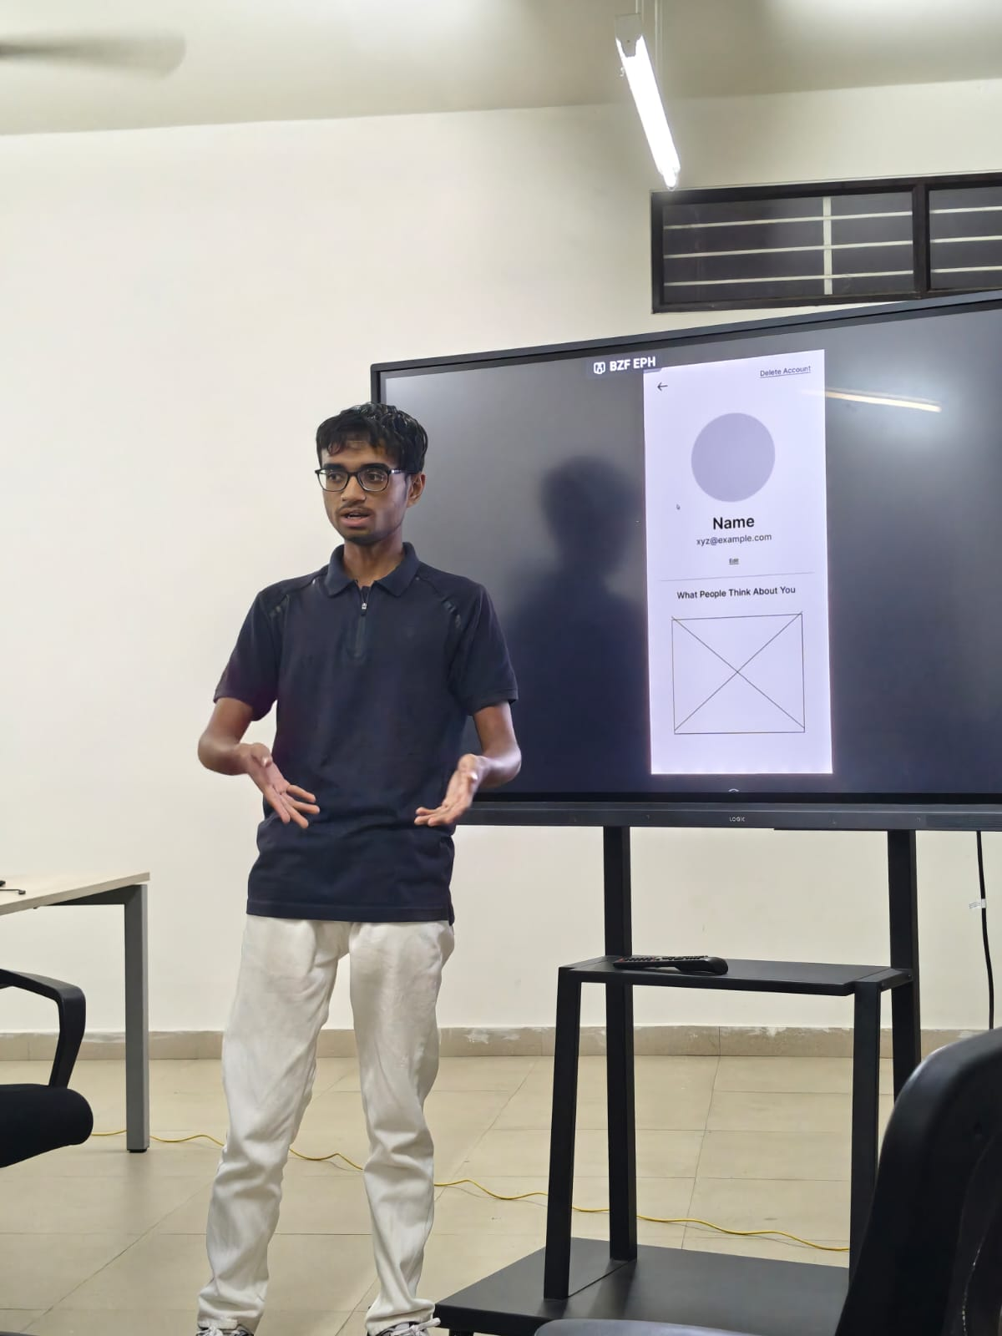

03. From Research to Interaction Design
One of the most important findings was that the QR scanner and personal QR code were the two primary actions students needed throughout the experience.
Instead of treating them as secondary features buried inside navigation menus, I proposed making both accessible directly from the homepage.
This decision was driven by the frequency and importance of these interactions. Students needed to quickly switch between scanning someone else's QR code and presenting their own without interrupting the social experience.
I mapped 10+ user flows covering the major interactions, including QR scanning, profile discovery, hobby guessing, gamified participation, and reward-related interactions.
I iterated on these flows based on stakeholder feedback, refining navigation and interaction patterns to make the experience intuitive and consistent.
Accessibility was another important consideration. I prioritized making the experience usable for students with disabilities, considering how navigation, information hierarchy, and interaction patterns could reduce unnecessary barriers.
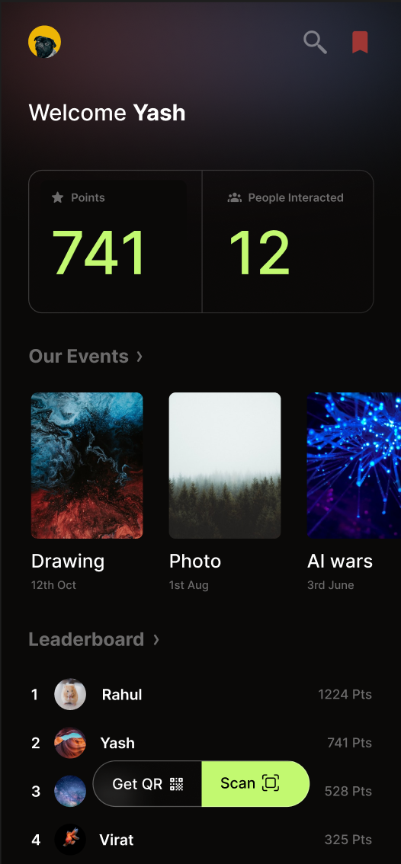

04. A Second Problem: Helping Students Understand CIA Labs
While working on the engagement experience, another usability problem became apparent.
Many students, particularly freshers, did not clearly understand what CIA Labs was, what it offered, or how they could get involved.
The existing information-heavy approach made discovering relevant information unnecessarily difficult. Students shouldn't have to understand the organization's structure before being able to find answers to basic questions.
I approached this as an information discovery problem rather than simply redesigning the homepage visually.
The proposed solution was a search-first homepage with a prominent search bar as the primary interaction. Instead of navigating through multiple sections, students could directly type questions about CIA Labs and what it does.
I designed an AI-powered conversational interface using Gemini Flash, which could interpret student queries and provide relevant answers through a modal interface.
This shifted the homepage experience from passive information consumption to active information discovery. Students could ask questions in their own words instead of having to figure out where information was located.
Visit : connect.cialabs.org , https://cialabs-homepage.vercel.app/ (Demo)
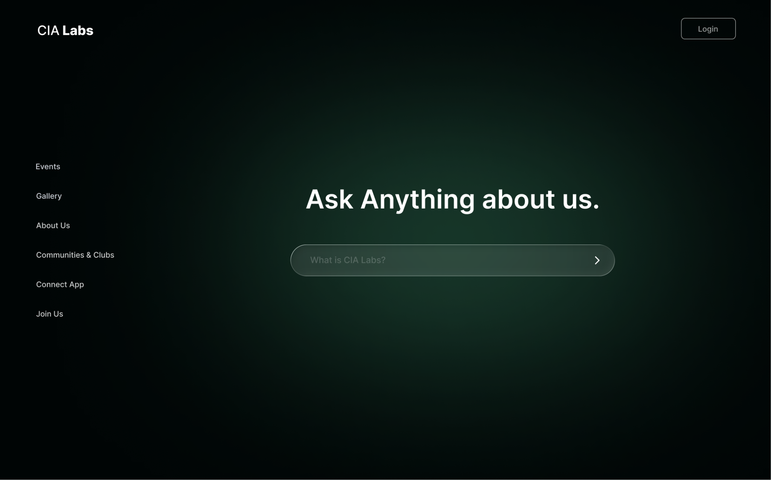

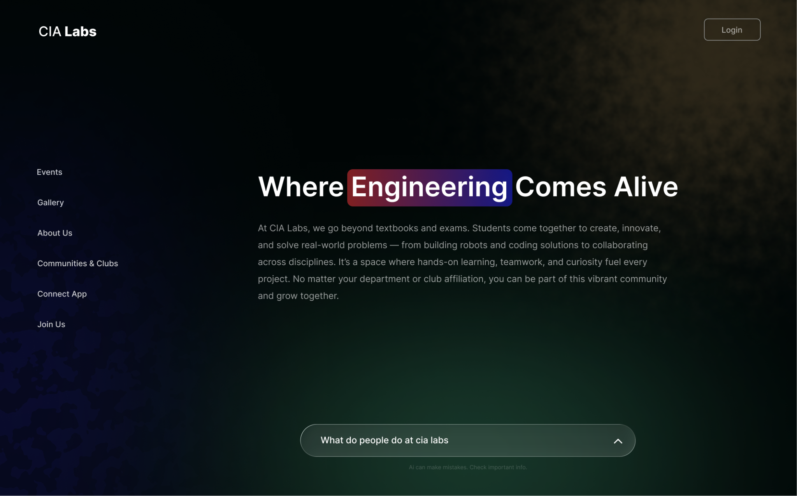

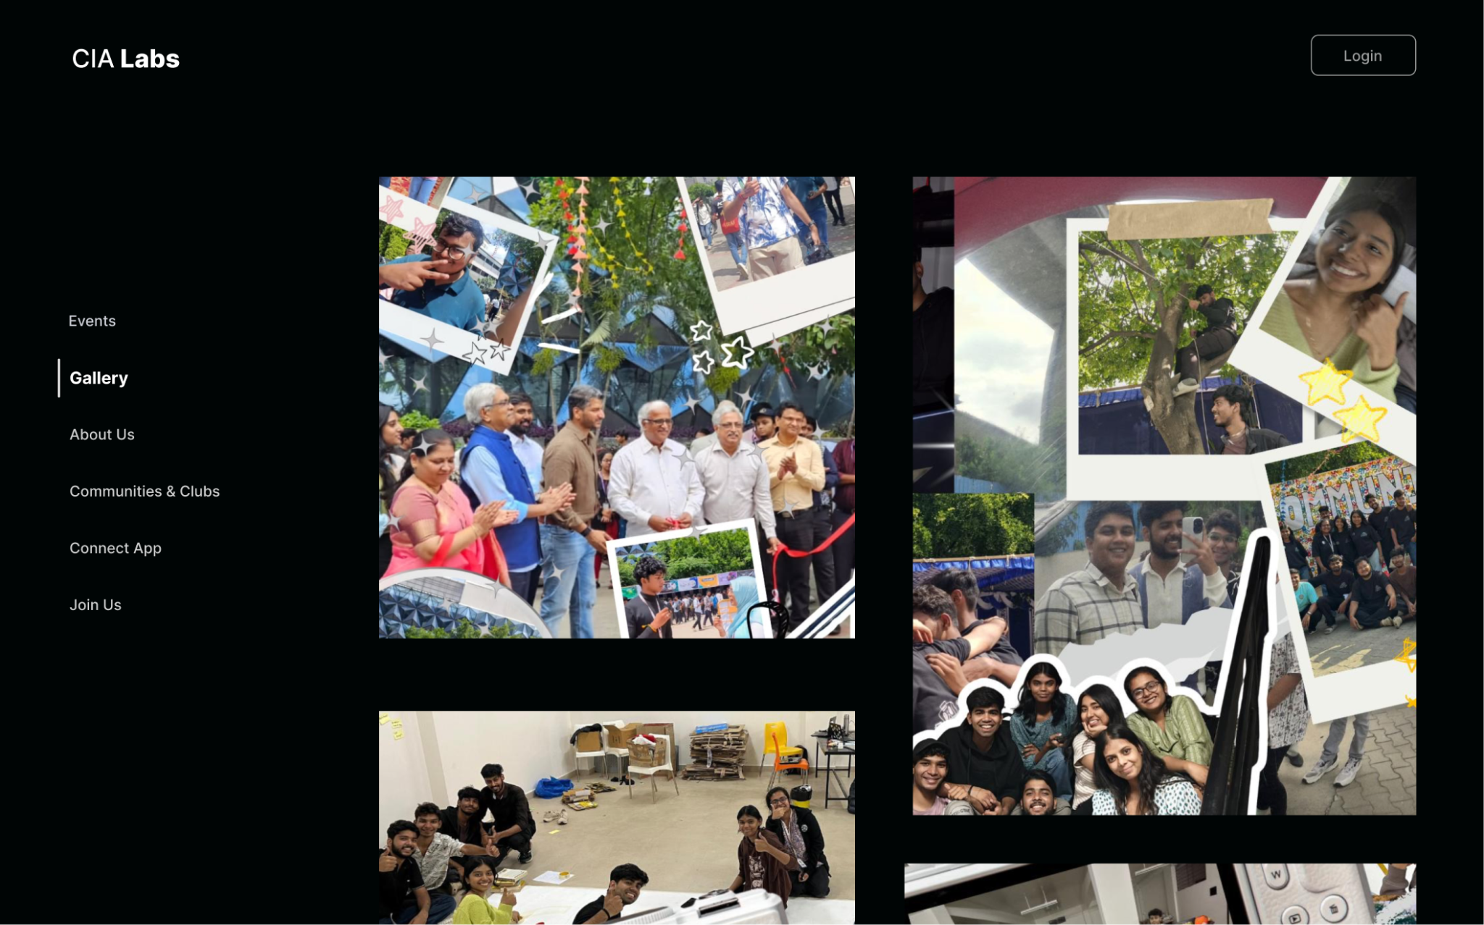

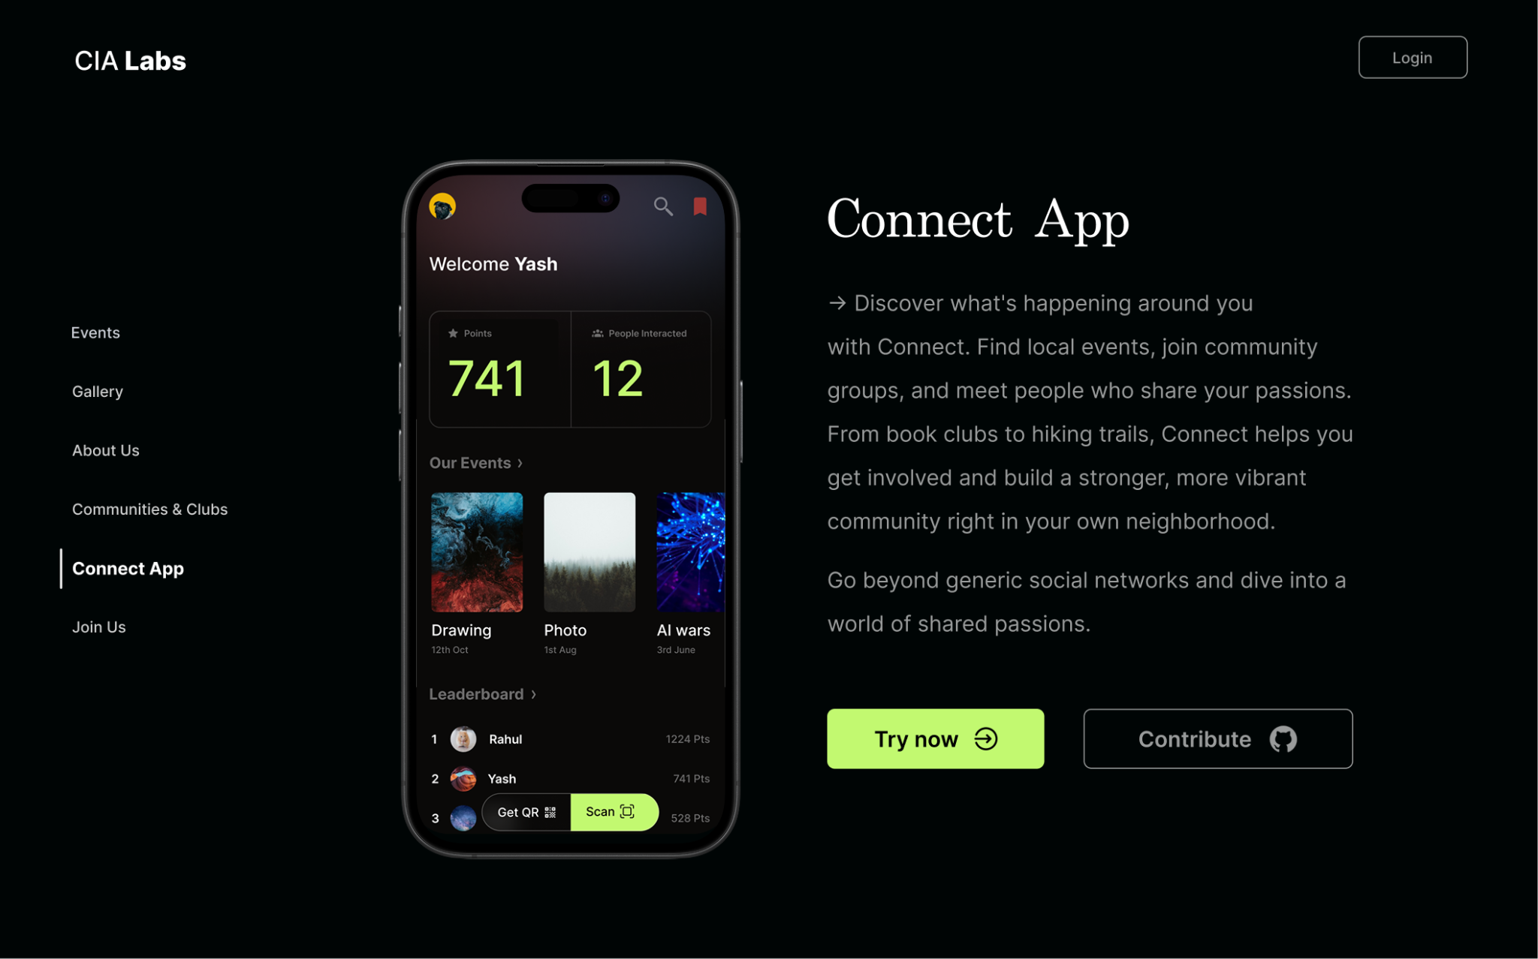

05. Outcome & Impact
The resulting experience brought together social discovery, QR-based interactions, and gamification into a single campus engagement platform.
The event-day experience supported 4,000+ concurrent users, demonstrating that the platform could accommodate significant participation during the college event.
The second homepage redesign introduced a more direct way for students and freshers to understand CIA Labs through natural-language queries, reducing dependence on navigating complex information structures.
More importantly, the project reinforced an approach I carry into product design: start with understanding what users are trying to accomplish, identify the friction preventing them from doing it, and make the most important interactions effortless.

Key Contributions
- 60 user interviews across graduating years.
- 10+ user flows designed and iterated.
- Accessibility considerations for students with disabilities.
- QR-first homepage interaction design.
- AI-powered information discovery using Gemini Flash.
- 4,000+ concurrent users supported on event day.
Tools & Technologies: Figma · Gemini Flash · QR-based Interactions

